Security Assessment Report
Cyber-Server CTF

Business Confidential
5 January 2026

Prepared by : Yara Darawsheh & Khaled Hanei

Contents
Sedna Industries Inc. Security Assessment Report 1
Assessment Overview 4
Assessment Components 4
Finding Severity Ratings 4
Risk Factors 5
Scope 5
Executive Summary 5
Technical Findings 6
Phase 1: Reconnaissance & Network Discovery 6
Phase 2: Scanning & Service Enumeration 7
Phase 3: Web Application Enumeration & Exploitation (Flag 1) 8
8
Figure 4: 8
9
Figure 5 : First Web Flag 9
Phase 4: Credential Attack & Initial Access (Flag 2) 9
Phase 5: Post-Exploitation Enumeration 11
Phase 6: Privilege Escalation (Flag 3) 11
Conclusion & Recommendations 12

Assessment Overview
This security assessment was conducted as part of an academic Capture The Flag (CTF) exercise targeting a deliberately vulnerable machine named "cyber-server". The goal of the assessment was to simulate a real-world penetration test and evaluate the security posture of the target system by progressing from an external attacker to full system compromise (root access).
The testing methodology followed structured penetration testing phases inspired by NIST SP 800-115, including reconnaissance, enumeration, exploitation, privilege escalation, and reporting.

Assessment Components
Internal Penetration Test The internal penetration test simulated an attacker with network-level access to the target host. The assessment focused on identifying exposed services, exploiting misconfigurations, and escalating privileges within the system.
Key stages included:
- Service Enumeration
- Web Application Testing
- Credential Attacks
- Post-Exploitation Enumeration
- Privilege Escalation

Finding Severity Ratings
Severity | CVSS v3 Score Ranges | Score Definition
Critical | (9.0–10.0) | Full system compromise
High | (7.0–8.9) | Unauthorized access
Medium | (4.0–6.9) | Partial exposure
Low | (0.1–3.9) | Minor weakness
Informational | (0.0) | No direct risk

Risk Factors
Likelihood: High Due to weak credentials, misconfigured sudo permissions, and insufficient access controls.
Impact: High Successful exploitation resulted in full root access to the system, compromising confidentiality, integrity, and availability.

Scope
Assessment Component Focus Area Internal Penetration Test 192.168.56.104
Scope Exclusions:
- No Denial of Service attacks
- No social engineering

Executive Summary

The assessment identified multiple critical security weaknesses within the target system. An exposed web service on port 8080 allowed unauthorized access to sensitive functionality, leading to disclosure of a web flag. Weak SSH credentials enabled unauthorized user access, which combined with misconfigured sudo permissions resulted in full root compromise.

Technical Findings

Phase 1: Reconnaissance & Network Discovery
Objective:
Identify live hosts within the internal network and determine the target machine’s IP address.
Methodology:
During this phase, passive and active network discovery techniques were used to identify systems reachable on the internal network. The tool Netdiscover was utilized to perform ARP-based scanning and detect active hosts.
Actions Performed:
- Executed Netdiscover on the internal network interface.
- Monitored ARP responses to identify live systems.
Results:
The target machine was successfully identified with the following IP address:
- Target IP: 192.168.56.104
This information was used as the foundation for further enumeration and scanning.

Figure 1: Using Netdiscover to identify active hosts

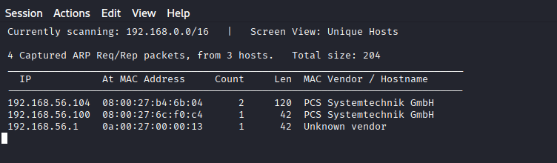
Figure 2 : Target IP discover

Phase 2: Scanning & Service Enumeration
Objective:
Identify open ports, running services, and potential attack vectors on the target system.
Methodology:
After identifying the target IP address, active scanning was performed using Nmap to enumerate open ports and discover running services and their versions.
Actions Performed:
- Conducted a full TCP scan using Nmap.
- Identified exposed services and service banners.
Results:
The scan revealed the following open ports and services:
- Port 22: SSH
- Port 80: HTTP (Apache Web Server)
- Port 8080: HTTP (Custom Web Application)
The presence of multiple web services and SSH indicated potential attack surfaces for exploitation.
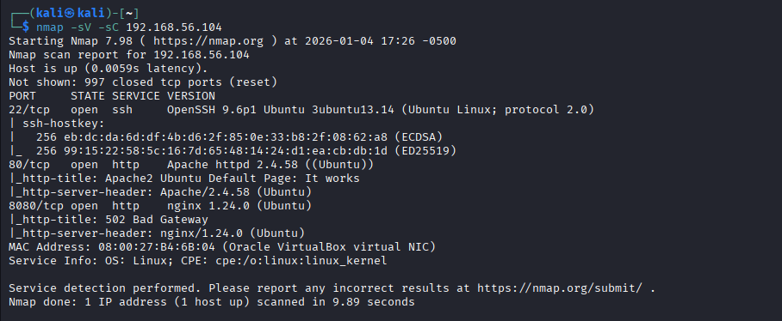
Figure 3 : Nmap scan results

Phase 3: Web Application Enumeration & Exploitation (Flag 1)
Objective:
Assess the security of the web application running on port 8080 and identify logic or access control flaws.
Methodology:
Manual web application testing was conducted by interacting directly with the application through a web browser. The application provided a functionality that accepted a user-supplied URL and performed a “check” operation.
Actions Performed:
- Accessed the web application on http://192.168.56.104:8080
- Tested application behavior with valid, invalid, and empty inputs.
- Observed server responses for inconsistencies.
Findings:
The application returned a flag even when no URL was supplied, indicating:
- Broken access control
- Flawed application logic
- Lack of input validation
Impact:
An unauthenticated attacker could retrieve sensitive information without providing valid input or credentials.
Result:
- Flag 1 successfully obtained via web exploitation

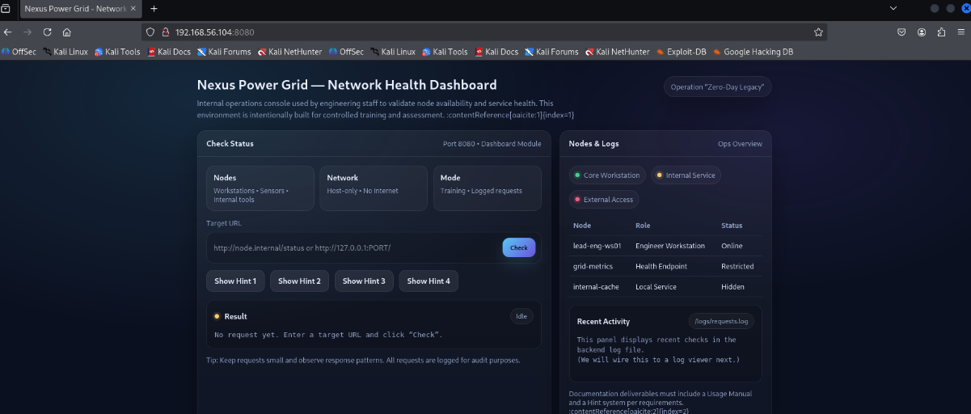

Figure 4: Scanning by the IP

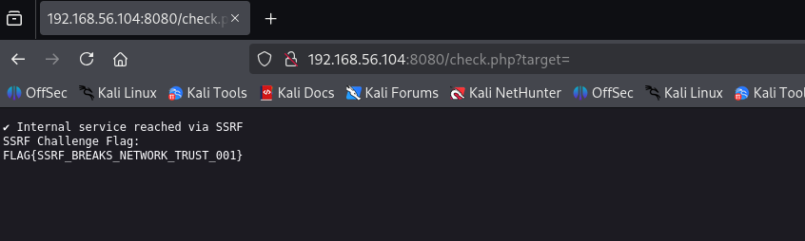

Figure 5 : First Web Flag

Phase 4: Credential Attack & Initial Access (Flag 2)
Objective:
Gain authenticated access to the system by exploiting weak authentication mechanisms.
Methodology:
Based on the exposed SSH service on port 22, a credential-based attack was performed. User enumeration identified a valid user account, which was then targeted using a brute-force attack.
Actions Performed:
- Identified a valid user account: theknower
- Used Hydra to perform a targeted brute-force attack against the SSH service.
- Successfully recovered weak credentials.
Recovered Credentials:
- Username: theknower
- Password: iloveyou
Results:
Using the recovered credentials, SSH access to the system was successfully obtained.
Impact:
An attacker could gain full shell access as a legitimate user.
User Flag Details:
- Location: /home/engineer_alpha/user.txt
- Flag Value: FLAG{ENGINEER_ACCESS}
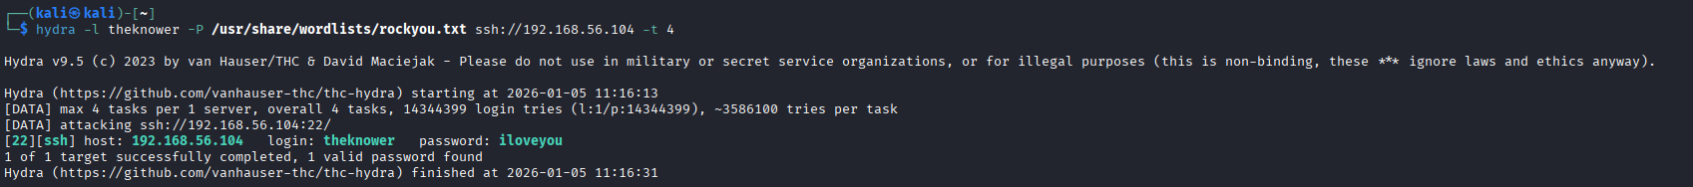
Figure 6 : Hydra successful login
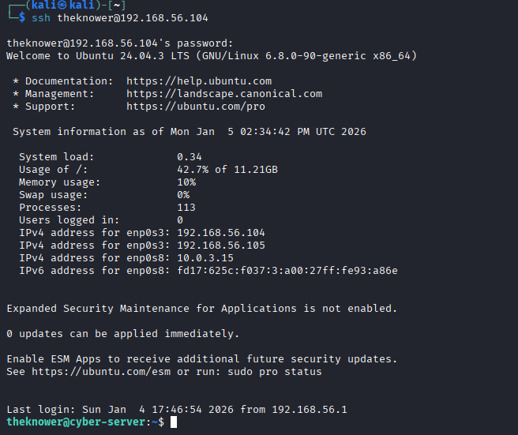
Figure 7 : SSH session as theknower
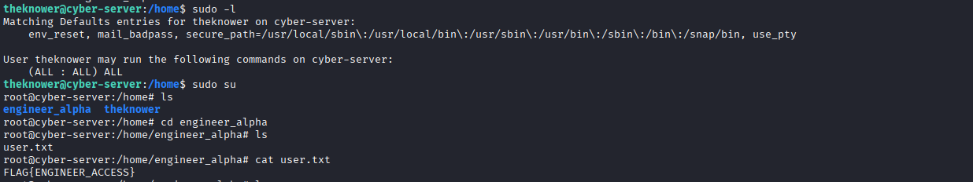
Figure 8: user.txt flag

Phase 5: Post-Exploitation Enumeration
Objective:
Identify privilege escalation opportunities after obtaining initial user access.
Methodology:
Post-exploitation enumeration was conducted to inspect user permissions, group memberships, and misconfigurations.
Actions Performed:
- Checked sudo privileges using the command:
- sudo -l
Findings:
The user theknower was found to have unrestricted sudo privileges:
(ALL : ALL) ALL
This configuration represents a critical security misconfiguration.
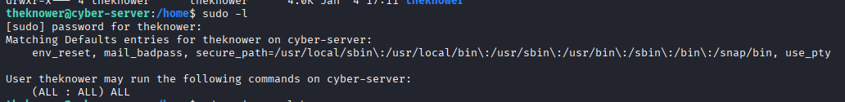
Figure 9 : sudo -l

Phase 6: Privilege Escalation (Flag 3)
Objective:
Escalate privileges from a standard user to root.
Methodology:
Given the unrestricted sudo permissions, privilege escalation was straightforward.
Actions Performed:
- Executed:
- sudo su
- Obtained a root shell.
Results:
Full root access to the system was achieved.
Root Flag Details:
- Location: /root/root.txt
- Flag Value: FLAG{ROOT_OWNED}

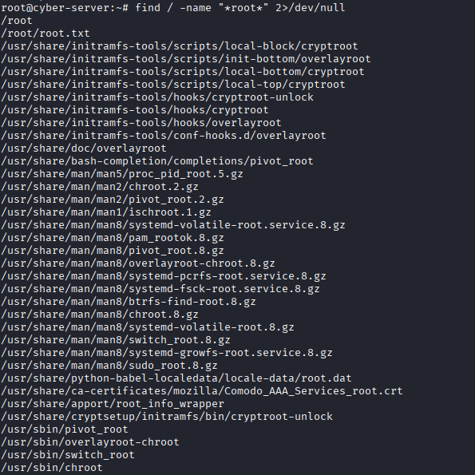
Figure 10 : finding the root.txt
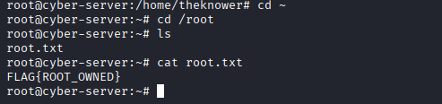
Figure 11 : root.txt flag

Conclusion & Recommendations
The target system was fully compromised due to a combination of web application logic flaws, weak authentication credentials, and improper privilege management.
Key Recommendations:
- Enforce authentication and access control on web applications
- Validate and sanitize all user input
- Enforce strong password policies
- Disable SSH password authentication where possible
- Restrict sudo privileges to only necessary commands
This assessment demonstrates the importance of defense-in-depth and secure configuration practices to prevent full system compromise.

